

ITERATION 1

DOCUMENTATION

INTRODUCTION 3

1. PROJECT OVERVIEW 4

1.1 STAKEHOLDERS 4

1.2 PROJECT OVERVIEW 6

1.2.1 FUNCTIONALITY PER USER 7

1.3 PROPOSED SOLUTION 9

2. PROJECT PROPOSAL 10

2.1 PROBLEM/OPPORTUNITY STATEMENT 10

2.2 HIGH-LEVEL USE CASE DIAGRAM 14

2.3 PROJECT OVERVIEW DIAGRAM 15

3. PROBLEM SPECIFICATION 16

3.1 FUNCTIONAL REQUIREMENTS 16

3.2 NON-FUNCTIONAL REQUIREMENTS 23

3.2.1 PORTABILITY 23

3.2.2 SECURITY 23

3.2.3 MAINTAINABILITY 23

3.3 SECURITY REQUIREMENTS 24

3.3.1 IDENTIFICATION AND AUTHENTICATION 24

3.3.2 ACCESS CONTROL 24

3.4 DATABASE REQUIREMENTS 25

3.4.1 INITIAL ERD DESIGN 28

3.5 USER INTERFACE REQUIREMENTS 29

3.5.1 LOW FIDELITY PROTOTYPES 30

4. CONCLUSION 35

5. APPENDICES 36

5.1 SLIDES 36

5.2 MINUTES OF MEETING 42

# INTRODUCTION

Group BIT is designing an Inventory Management System (I.M.S) designed to keep track of inventory to be used by the local municipality technical department employees.

We have chosen this project to gain exposure to a real world working environment, getting the opportunity to communicate directly with a client, and using new technology to make this project a reality.

Contained within this document will be the Project Overview, Project Proposal, Project Specifications and Conclusion.

# 1. PROJECT OVERVIEW

## 1.1 STAKEHOLDERS

Group Name: Building Innovative Technology (BIT)

Project Name: Inventory Management System (I.M.S)

|  |  |  |  |
| --- | --- | --- | --- |
| **Group Members** | **Student Number** | **Email Address** | **Signatures** |
| Samuel Walsh | s216471788 | s216471788@mandela.ac.za |  |
| Justin Hein | s215109465 | s215109465@mandela.ac.za |  |
| Neerav Panchal | s216324181 | s216324181@mandela.ac.za |  |
| Robbert Conradie | s216006554 | s216006554@mandela.ac.za |  |
| Mauritz Langeveld | s216316758 | s216316758@mandela.ac.za |  |

|  |  |  |
| --- | --- | --- |
| **SUPERVISOR** | | |
| **Name** | **Email** | **Signature** |
| Mr. Dieter Steenberg | dieter.steenberg@mandela.ac.za |  |

|  |  |  |
| --- | --- | --- |
| **USER** | | |
| **Name** | **Email** | **Signature** |
| Mr. Forrest Walsh | fwalsh@mandelametro.gov.za |  |

## 

|  |  |  |  |  |  |
| --- | --- | --- | --- | --- | --- |
| **Project Group Role Matrix** | | | | | |
| **First Name** | Justin | Mauritz | Neerav | Robbert | Samuel |
| **Surname** | Hein | Langeveld | Panchal | Conradie | Walsh |
| **Student Number** | s216316758 | s215109465 | s216324181 | s216006554 | s216471788 |
| **Myers-Briggs Personality Type** | Architect | Executive | Protagonist | Logician | Logician |
| **ROLE** |  | | | | |
| **Project**  **Manager** |  |  |  |  | P |
| **Systems**  **Analyst** | S | P |  | S |  |
| **Systems**  **Designer** | P |  | S |  |  |
| **Database Designer** |  |  |  | S | P |
| **Interface Designer** |  |  | P |  | S |
| **Technical Researcher** | P | S |  |  |  |
| **Document**  **Writer** | S | P |  |  | S |
| **Coder** |  |  | P | P |  |
| **Tester** |  | S | S | P |  |

## 

## 

## 1.2 PROJECT OVERVIEW

The proposed system will be addressing a problem for the local municipality with their inventory management, as currently there is no system in place to organize and catalogue their inventory.

The user Forrest Walsh and **\**technical department employees*** from the local municipality, would like to have an inventory management system with geotagging to keep track of inventory and current location. He would like to be mobile, reliable, usable and quick, and easy to use. It must be adaptable to unique needs of that specific section, to control what is seen by themselves and other departments.

When the need arises, they need to let the auditor be able to view the inventory, and this system will help make this process quicker. This project solution must be able be usable across multiple operating systems, hence why have chosen to make it a server-based project with web browser and mobile interface. It is primarily a database system that can be accessed from a website. This more driven to the services being provided by a server as the users want a quick on the go solution so the project will be heavily driven towards a friendly mobile website. This system will as help keep track of movement of inventory with the three-w rule (who, what, where). The system will be used as needed, when adding and updating inventory and they will need to be able to do this on local site of the municipality as well as offsite at substations, rtu (remote terminal unit), and if needed the employee can view inventory from home on their mobile phones and desktops.

The section and department heads will be able to view the inventory and make changes to the data, as well determine what the employees below them as to how they will see and interact with the system. The auditors will only be able to view the inventory but make to changes to the database. The standard employee will only be able to add a new item to the database, update a specific item (the location and condition if necessary) and view the information description of an item and settings attached to the item (and make changes if they have been given permission).

The intent for the system is for the user to use their mobile device and scan a barcode to update that item’s location and condition, hence opting for a web-based database website.

***\*Communication, Protection, Radio***

### 1.2.1 FUNCTIONALITY PER USER

|  |  |
| --- | --- |
| ***User*** | ***Functionality*** |
| ***Admin***  *IT Technician* | Validate/void user privileges. |
| Create a temporary guest user account. |

|  |  |
| --- | --- |
| ***User*** | ***Functionality*** |
| ***Unregistered User*** | Will have no privileges on the system. |

|  |  |
| --- | --- |
| ***User*** | ***Functionality*** |
| ***Registered User***  *Auditor* | View inventory for all sections (Communications, Radio and Protection**).** |
| Login with temporary guest user account. |
| Generate a pdf of inventory. |

|  |  |
| --- | --- |
| ***User*** | ***Functionality*** |
| ***Registered User***  *Department Head* | View inventory for all sections (Communications, Radio and Protection**).** |
| Login with temporary guest user account. |
| Generate a pdf of inventory. |
| Generate a pdf of transaction history. |

|  |  |
| --- | --- |
| ***User*** | ***Functionality*** |
| ***Registered User***  *Section Heads* | Add inventory. |
| Update inventory. |
| View information of inventory. |
| Get location of inventory. |
| Generate a barcode of new/old inventory. |
| Generate a pdf of inventory. |
| View history of transactions of inventory. |
| Create/modify group user policy. |
| Generate a pdf of transaction history. |

*\*Communications, Radio and Protection*

|  |  |
| --- | --- |
| ***User*** | ***Functionality*** |
| ***Registered User***  *\*Technical Department Employee* | Add inventory. |
| Update inventory. |
| View information of inventory. |
| Get location of inventory. |
| Generate a barcode of new/old inventory. |

*\*Communications, Radio and Protection*

## 1.3 PROPOSED SOLUTION

As stated above, the problem can be solved by tracking who uses what specific item from the inventory and where the specific item is located.

When an employee wishes to use the Inventory Management System (IMS), they can access it using a web browser on either their computer, or their smartphone to view and interact with the system.

Hence, the registered users will be able to track the inventory location; by using the location of the smartphone GPS coordinates as the device will be updating the inventory’s details with the scanning of a barcode linked only to that item. With the previous being said all interactions with any and all inventory will have a traceable history of use, with only the section head having rights to view these interactions.

The information regarding where the items are, who used the specified item, and store the inventory item’s location and will stored using the MariaDB engine, hosted on a server in the local Municipality’s site.

The front-end programming will be done using HTML and Angular, and the back end programming will be done using the PHP7 and JavaScript.

We are using the proposed technologies as they are open-source, as well as having the added benefit of what most of the IT industry is pushing towards using. With the use of GitHub repository to store our source code.

We are using phpMyAdmin to manage our database, and using PHP Eclipse IDE to develop and manage our source code.

# 2. PROJECT PROPOSAL

## 2.1 PROBLEM/OPPORTUNITY STATEMENT

|  |  |
| --- | --- |
| **The PIECES Framework** | |
| **Performance** | Their performance is hindered as currently there is no system in place, and their response time to a fault or general work activities is poor as the user must manually check every time where the inventory’s equipment is before usage, as the equipment could have been lent to a sub department within the technical department. |
| **Information (and Data)** | **Outputs**  There is a lack of any information as to where any of the inventory’s equipment is, as the primary method to relay information is word of mouth and in this format the information may be inaccurate.  **Inputs**  Since this is primarily a word of mouth system that is currently in use, there is not data to capture as to where the inventory’s equipment is, and if the need arises when an auditor comes to validate the legitimacy of the dealings, it will take time to escort them to and from the various locations to maybe legitimize one new piece of equipment.  **Stored Data**  Any form of data they have on any piece of the inventory’s equipment is null and void as there is no real system in place to keep track of the comings and goings of equipment, other than when the equipment was bought and sold. As such a centralized location of data and information is necessary to validate claims as to where the equipment is. |
| **Economics** | The value of equipment in each inventory is the date of purchase and the day of selling, no accurate way to measure the depreciation of equipment, as there are no digital images to see where and what might have written of the equipment. Hence the system the team is developing will cater for image history of the equipment to have a more accurate understanding of the history of that equipment. |
| **Control (and Security)** | With the current system in place, fraud can be committed against any known data thus becoming null and void. Thus, decision making errors can occur, such as reordering of the same equipment as there is not always a paper trail to backtrack any decisions made by the sub departments. The system in which the team is developing will keep track of where and when the equipment was placed and/or is in use. |
| **Efficiency** | In the current system more than required effort is required to locate and track down where the inventory’s equipment is. In the system the team is developing each piece of equipment will have a geolocation coordinate attached to it in the system and will require the user to update it when/if moved. |
| **Service** | The current system produces inconsistent and unreliable results, hence the reason for the system in development will address this issues with a centralized storage of data and information. |

## 

## 

|  |
| --- |
| **PROJECT SCOPE** |
| **Information Scope** |
| **Section Head:**  ● Must Haves  o View history of equipment movement  o View location of equipment  o View specific equipment details  o View group policy  ● Should Have  o View equipment details that have been disposed or removed  ● Could Have  o View Image of equipment    **Technical Employee:**  ● Must haves  o View equipment details  o View location of equipment    **Authorized Guest:**  ● Must Haves  ○ View Report  **I.T Department Employee:**  ● Must Haves  ○ View User Details |
| **Functional Scope** |
| **Section Head:**  ● Must Haves  o Login  o Add/Update/remove inventory item  o Locate equipment  o Generate PDF document  o Define group user policy  **Technical Employee:**  ● Must Haves  o Login  o Locate inventory and inventory items  o Add/update the inventory details  **Authorized Guest:**  ● Must Haves  o Login  o Generate reports  **I.T Department Employee:**  ● Must Haves  o Login  o Create Authorized guest  o Void user details |
| **Communications Scope** |
| ● Must Haves  o Export to PDF  ● Should Have  o The ability to auto email at the end of x time to send a PDF of that amount of times history of events.  ● Could Have  o Flagging old stock |

## 2.2 HIGH-LEVEL USE CASE DIAGRAM

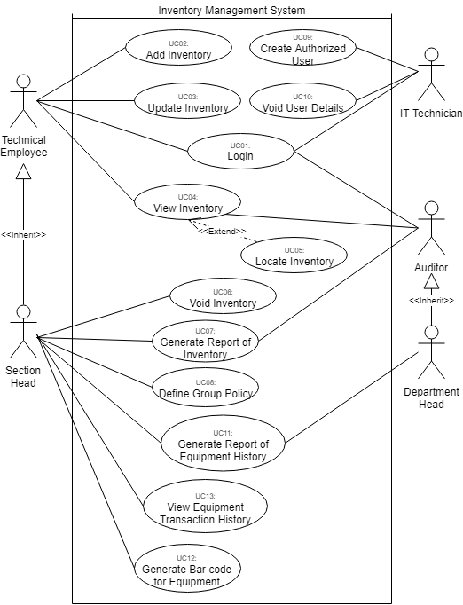

## 2.3 PROJECT OVERVIEW DIAGRAM

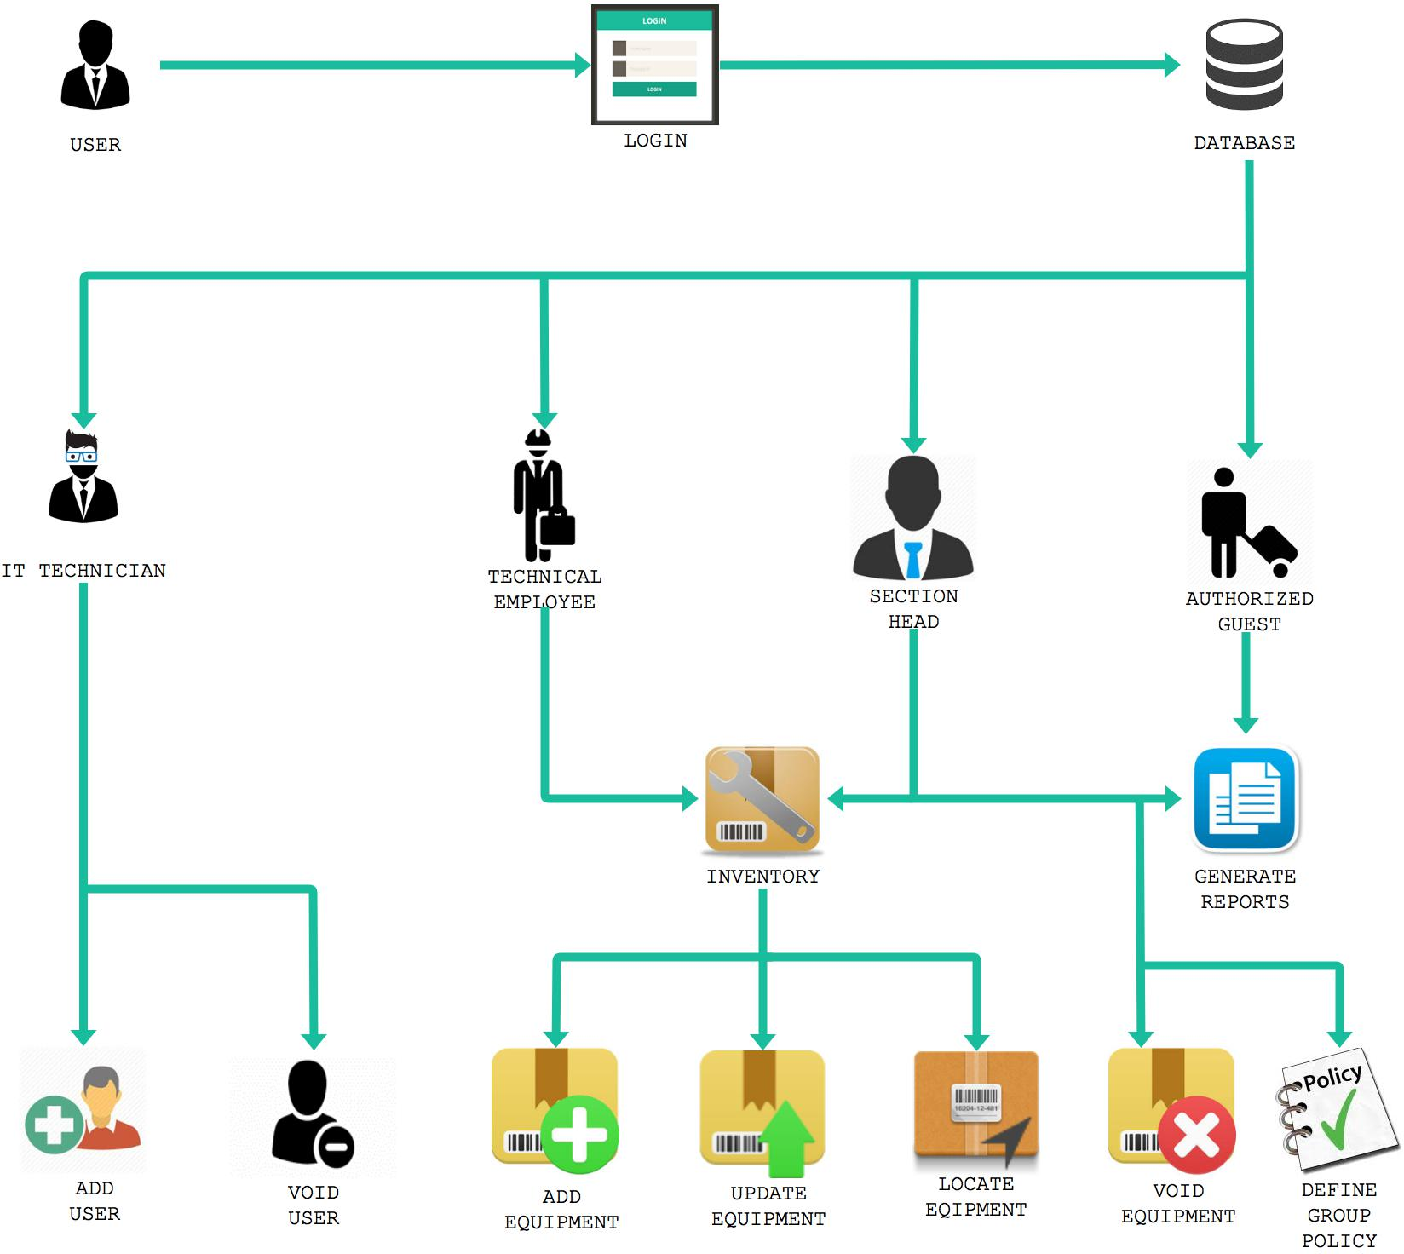

# 3. PROBLEM SPECIFICATION

## 3.1 FUNCTIONAL REQUIREMENTS

|  |
| --- |
| **Login UC01** |
| Purpose: Allow authorized users, or authorized guests to log into the system. |
| Input: Username and password. |
| Process: Password will be encrypted in 128-256 bit while in use and when stored in database.  The system will check the entered credentials against the database to see if the person is an authorized user, and what level of user they are. |
| Output: User is logged in and able to access the Inventory management, according to their level of access. Unauthorized people will not be able to enter the system. |

|  |
| --- |
| **Add Inventory UC02** |
| **Purpose** – Allow users, mainly the technical employees, to add new equipment to the database either manually, through a barcode scanner or their phone camera. The equipment’s location is also geo-tagged, along with the employee who made the addition. |
| **Input** – Equipment details (and employee who made it), such as barcode number and location data, taken through as a string(s), as some barcodes have alphanumeric, and the location data is in coordinates. |
| **Process** – Equipment details are sent from either a phone or desktop to the equipment table and history of use table in the database sitting on the server. 128-256 bit encryption will be used. |
| **Output** – New equipment is added to the equipment table in the database, a message will appear saying the insert was successful. Errors will be handled depending on whether it went through or not. The new equipment is also logged in a history of use table. |

|  |
| --- |
| **Update Inventory UC03** |
| **Purpose** – Update the equipment details in the equipment table in the database, as well as the user who performed the update and where the update was made. |
| **Input** – Relevant equipment details, plus the user who made the change and the location data where the change was made. |
| **Process** – Update data is sent to the server where the equipment table and history of use table in the database are. 128-256 bit encryption will be used. |
| **Output** – Update has been performed on the equipment table, and logged in the history of use table. An error message will appear if the update was not successful. |

|  |
| --- |
| **View Inventory UC04** |
| **Purpose** – Employee’s or the Section head can view equipment details to make decisions pertaining to day to day activities and tasks, or view history of use. |
| **Input** – Equipment details a user might want to view. A user enters the view screen/form and looks at equipment details. Any specific search is processed. |
| **Process** – The system shows equipment details the user requests by fetching it from the equipment and/or history of use. 128-256 bit encryption will be used. |
| **Output** – Requested equipment details and information is displayed for the employee or section head to view. |

|  |
| --- |
| **Locate Inventory UC05** |
| **Purpose** – To find the locations of the equipment and who that equipment is being used by. |
| **Input** – Equipment details, such as brand, which employee took it out, whatever detail the employee want to search by or by selecting the locate button when using the view equipment screen. |
| **Process** – Equipment identifier is used to search out and retrieve the location data from the equipment table. |
| **Output** – The location of the equipment piece in question is returned. |

|  |
| --- |
| **Void Inventory UC06** |
| **Purpose** – For the Section head to remove equipment from the database. |
| **Input** – Details of equipment (or many pieces of equipment) the section head wants to remove. |
| **Process** – The system finds the record that is to be removed, then disables its status to inactive. A record is logged into an ‘archive’ type table as well as history of use table. In the case of a batch delete, or at request of upper management, a pdf is prepared. |
| **Output** – Deleted equipment records are never seen or used by the system again. An inactive record cannot be used by the database. Only Record of its existence will be kept in the archive and history of use table. A pdf is created with the details of the delete. |

|  |
| --- |
| **Generate Report of Inventory UC07** |
| **Purpose** – Section Head can generate a report on the equipment, such as history of use of a batch of equipment, specific pieces of equipment, disposed of equipment, etc. |
| **Input** – Input depends on what the Section head wants to generate a report on. The input would almost always involve the equipment ID, its status and history log ID. |
| **Process** – search parameters are sent to the database and the requested information is drawn from the necessary tables. |
| **Output** – The system the automatically generates a report in pdf format for the section head. |

|  |
| --- |
| **Define Group Policy UC08** |
| **Purpose** – The Section Head must define the group policy of the use of the system, who has what privileges, rules, user limits and such. |
| **Input** – Section Head goes to the group policy document and edits it through the system or manually. |
| **Process** – Section head carries out changes to group policy for whatever is deemed needed. |
| **Output** – The group policy is revised for all employees and affected parties to view. |

|  |
| --- |
| **Create Authorized User UC09** |
| **Purpose** – For the IT technicians to create an authorized user account. |
| **Input** – IT technicians access the system functionality or activating or creating a new guest account for the guest. |
| **Process** – IT technicians create a new record or re-activate an old guest account in the guest table. |
| **Output** – An authorized user is created. |

|  |
| --- |
| **Void user details UC10** |
| **Purpose** – IT technicians can delete and remove employees, section heads or authorized guests’ accounts if they are fired or retire. |
| **Input** – IT technicians open up the void user details screen, and proceed to select who is to be removed from the system. |
| **Process** – employee record is first deleted, and then a log table keeps track of all employees who have been removed before. |
| **Output** – A message saying that the selected employee has been removed. |

## 

|  |
| --- |
| **Generate Report of Equipment History UC11** |
| **Purpose** – Allow the Section Head And Department Head to generate a transaction log of Equipment |
| **Input** – User selects Equipment from a table. |
| **Process** – search parameters are sent to the database and the requested information is drawn from the necessary tables. |
| **Output** – A pdf report is generated and displayed containing the transaction of the equipment. |

## 

|  |
| --- |
| **Generate Barcode of Equipment UC12** |
| **Purpose** – Allow the Section Head to generate a barcode for the equipment. |
| **Input** – Selects option from menu. |
| **Process** – A unique barcode is generated containing numbers and/or letters. |
| **Output** – The barcode along with municipal header are displayed. |

## 

|  |
| --- |
| **View Equipment Transaction History UC13** |
| **Purpose** – Allow the user to view the equipment’s transaction history. |
| **Input** – User selects Equipment. |
| **Process** – search parameters are sent to the database and the requested information is drawn from the necessary tables. |
| **Output** – Transaction history of the selected equipment is displayed in a table containing the date of transaction, the user of the equipment, the logged location, and the equipment’s condition. |

## 

## 3.2 NON-FUNCTIONAL REQUIREMENTS

### 3.2.1 PORTABILITY

The system will be a server based that will be accessible on both desktop and mobile devices. Angular will be used to make the system usable on smart mobile devices so that the user may access the system from remote locations.

### 3.2.2 SECURITY

Users will use encrypted passwords and usernames to log into the system. Encryption will be used to encrypt login details, mostly lightly 128-bit encryption. Unauthorized users will be prevented from logging in and a message will inform them that they have entered invalid login details.

### 3.2.3 MAINTAINABILITY

The system is made for use by the local municipality’s technical department to keep track of inventory equipment. The section head will be informed of changes to the equipment status. Section Head and Technical employee are able to add and update equipment. The Section Head can also void equipment that's been expired.

## 3.3 SECURITY REQUIREMENTS

### 3.3.1 IDENTIFICATION AND AUTHENTICATION

Our Inventory Management System requires different types of employees and other non-municipal employees, who also have different roles and should therefore, have different privileges when using the system.

Authentication will involve a user entering their username and password to access the system. To ensure security, a user will have a predefined level of access their role grants them, for example: a technical employee and the section head may be able to perform some of the same functions (see use case diagram), but a section head will be able to use more system functions than the technical employee, i.e. have a higher level of access than them.

### 3.3.2 ACCESS CONTROL

A login page will be mandatory for an employee to access any functionality of the system. The passwords and usernames will be stored in the database securely, using the built in functions of encrypting password fields. When passing data from the client to the server, 128 or 256 bit encryption will be used, depending the requirements given by the IT admin at the local municipality.

To ensure data integrity, the usernames and passwords will be linked to the roles of the employee and those roles privileges. Various levels of security will be implemented and used to secure our database by structuring our system using n-tier architecture, using proper-error handling and encryption techniques and secure data transfer protocols between client and server.

User rights, roles, privileges and authorization levels will be defined in the group policy document, to be determined/edited/modified as needed by the section head.

## 3.4 DATABASE REQUIREMENTS

|  |  |  |
| --- | --- | --- |
| **Entity** | **Attributes** | **Business rules for storing, processing or transmitting data** |
| **USERDETAILS** | User ID, Username, User First Name, User Surname, User Date Of Birth, User Email, Secret Question ID, User Secret Question, Role ID, Login ID | 1. A User may not be added without an ID number. 2. All the User’s personal details must be included. 3. A security question and an answer must be provided by the User. |
| **LOGIN** | Login ID, Username, Password | 1. Each User is identified by username. 2. A username and password must be kept |
| **TECH_DEPARTMENT_USER** | User ID, Position ID, Position Description | 1. The user’s position must require an ID. 2. The description regarding the user’s position must be specified. |
| **SECRET QUESTION** | Secret Question ID, Secret Question Name, Secret Question Description | 1. Each security question must have an ID. 2. Each security question must have a description. |
| **ROLES** | Roles ID, Role Name, Role Description | 1. Each policy must have an ID. 2. The specified policy are provided to specific users. |
| **ROLE_PERMISSION** | Role ID, Permission ID | 1. The specified policy are provided to specific users. 2. Each policy has a description. |
| **PERMISSION** | Permission ID, Permission Name, Permission Description | 1. Each permission must have an ID. 2. Each Permission must have a name. |
| **SECTION** | Section ID, Section Name, Section Description | 1. Every section in the department has an ID. 2. A description of the department must be provided. |
| **EQUIPMENT_HISTORY** | Equipment History ID, Equipment ID, Inventory ID, Equipment History Date, Equipment History Time, Equipment History Location, Equipment History Picture, User ID | 1. All the attributes will bring back the users’ history of equipment used, the equipment’ status, the equipment’s current status picture, and the equipment’s location. |
| **EQUIPMENT** | Equipment ID, Item ID, Date of Purchase, Date of Commission, Equipment Status, Equipment Item Status Picture, Equipment Location | 1. An ID for each equipment item piece is required. 2. The item’s date of purchase must be included. 3. The date of commission is necessary. 4. A picture of the item’s current state must be provided. 5. The item’s specific location must be included. |
| **EQUIPMENT** | Equipment ID, Inventory ID, Equipment Date of Purchase, Equipment Date of Commission, Equipment Status, Equipment Status Picture, Equipment Location, Equipment Quantity | 1. Each equipment must have an ID. 2. Each equipment’s date of release must be present. 3. The equipment’s quantity in stock must be consistent. |
| **INVENTORY** | Inventory ID, Inventory Brand ID, Inventory Type ID, Inventory Name, Inventory Description, Inventory Date of Commission | 1. Each inventory is identified by an ID. 2. The Inventory’s Brand ID must be kept. 3. The inventory’s date of commission must be kept. |
| **INVENTORY BRAND** | Inventory Brand ID, Inventory Name | 1. The Inventory’s Brand ID must be kept. 2. The Inventory’s Brand must have a name. |
| **INVENTORY TYPE** | Inventory Type ID, Inventory Type Name, Inventory Type Description | 1. The Inventory’s Type ID must be kept. 2. The Inventory’s Type must have a name. |
| **EQUIPMENT DISPOSE BATCH** | Dispose Batch ID, Equipment ID, Inventory ID | 1. The Dispose Batch must be specified through a unique ID. 2. The Equipment ID and the Inventory ID must be included. |
| **DISPOSE BATCH** | Dispose Batch ID, Dispose Batch Date | 1. The Dispose Batch must be specified through a unique ID. 2. The Dispose Batch requires a date for when it got disposed of. |

### 3.4.1 INITIAL ERD DESIGN

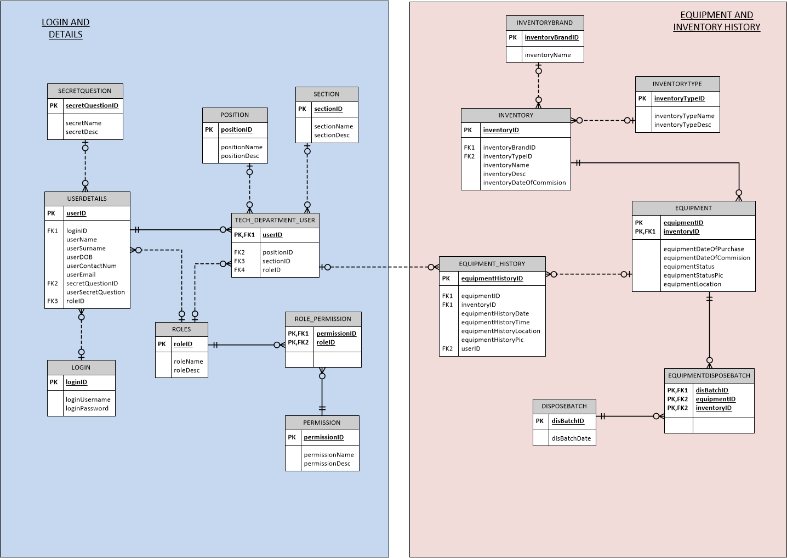

## 

## 3.5 USER INTERFACE REQUIREMENTS

|  |  |
| --- | --- |
| * Effective to use (effectiveness) | * The user interface will be designed in a way that will cater for all core functionality of the **Inventory Management System.** * This system will be custom made to suit the necessities of the Electrical Department**, Adding Equipment, Locating Equipment and Generating reports etc.** * The user interface will be made simply for the completion of essential activities. |
| * Efficient to use (efficiency) | * For every process, such as **Adding Equipment, Locating Equipment,** certain compulsory steps are to be followed. * The user interface provides clear features and guidelines of procedures that need to be done with well-organized methods to complete the necessary procedures. |
| * Safe to use (safety) | * Undesirable situation will be approached in a way as to protect the user against unwanted actions; we require the user to be confident in order to be as efficient as possible with the system. * For example disposing of a batch off equipment by accident. |
| * Have good utility (utility) | * The system has the ability to satisfy the needs and wants of the user by providing precise services to the user. |
| * Easy to learn (Learnability) | * The user interface will be designed in a manner to suit the user's needs, therefore it will be easy to learn. |
| * Easy to remember how to use (memorability) | * Without any unnecessary functions, the user will certainly have a user friendly experience and learn to use the system in no time. * The user will be able to remember how to use the system even after not using it for too long, they will be able to remember exactly how to use it with ease. |

### 3.5.1 LOW FIDELITY PROTOTYPES

*Login*

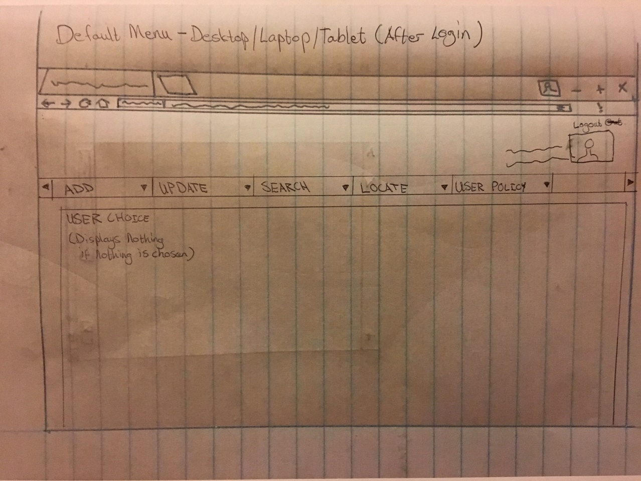Default Menu

View Equipment

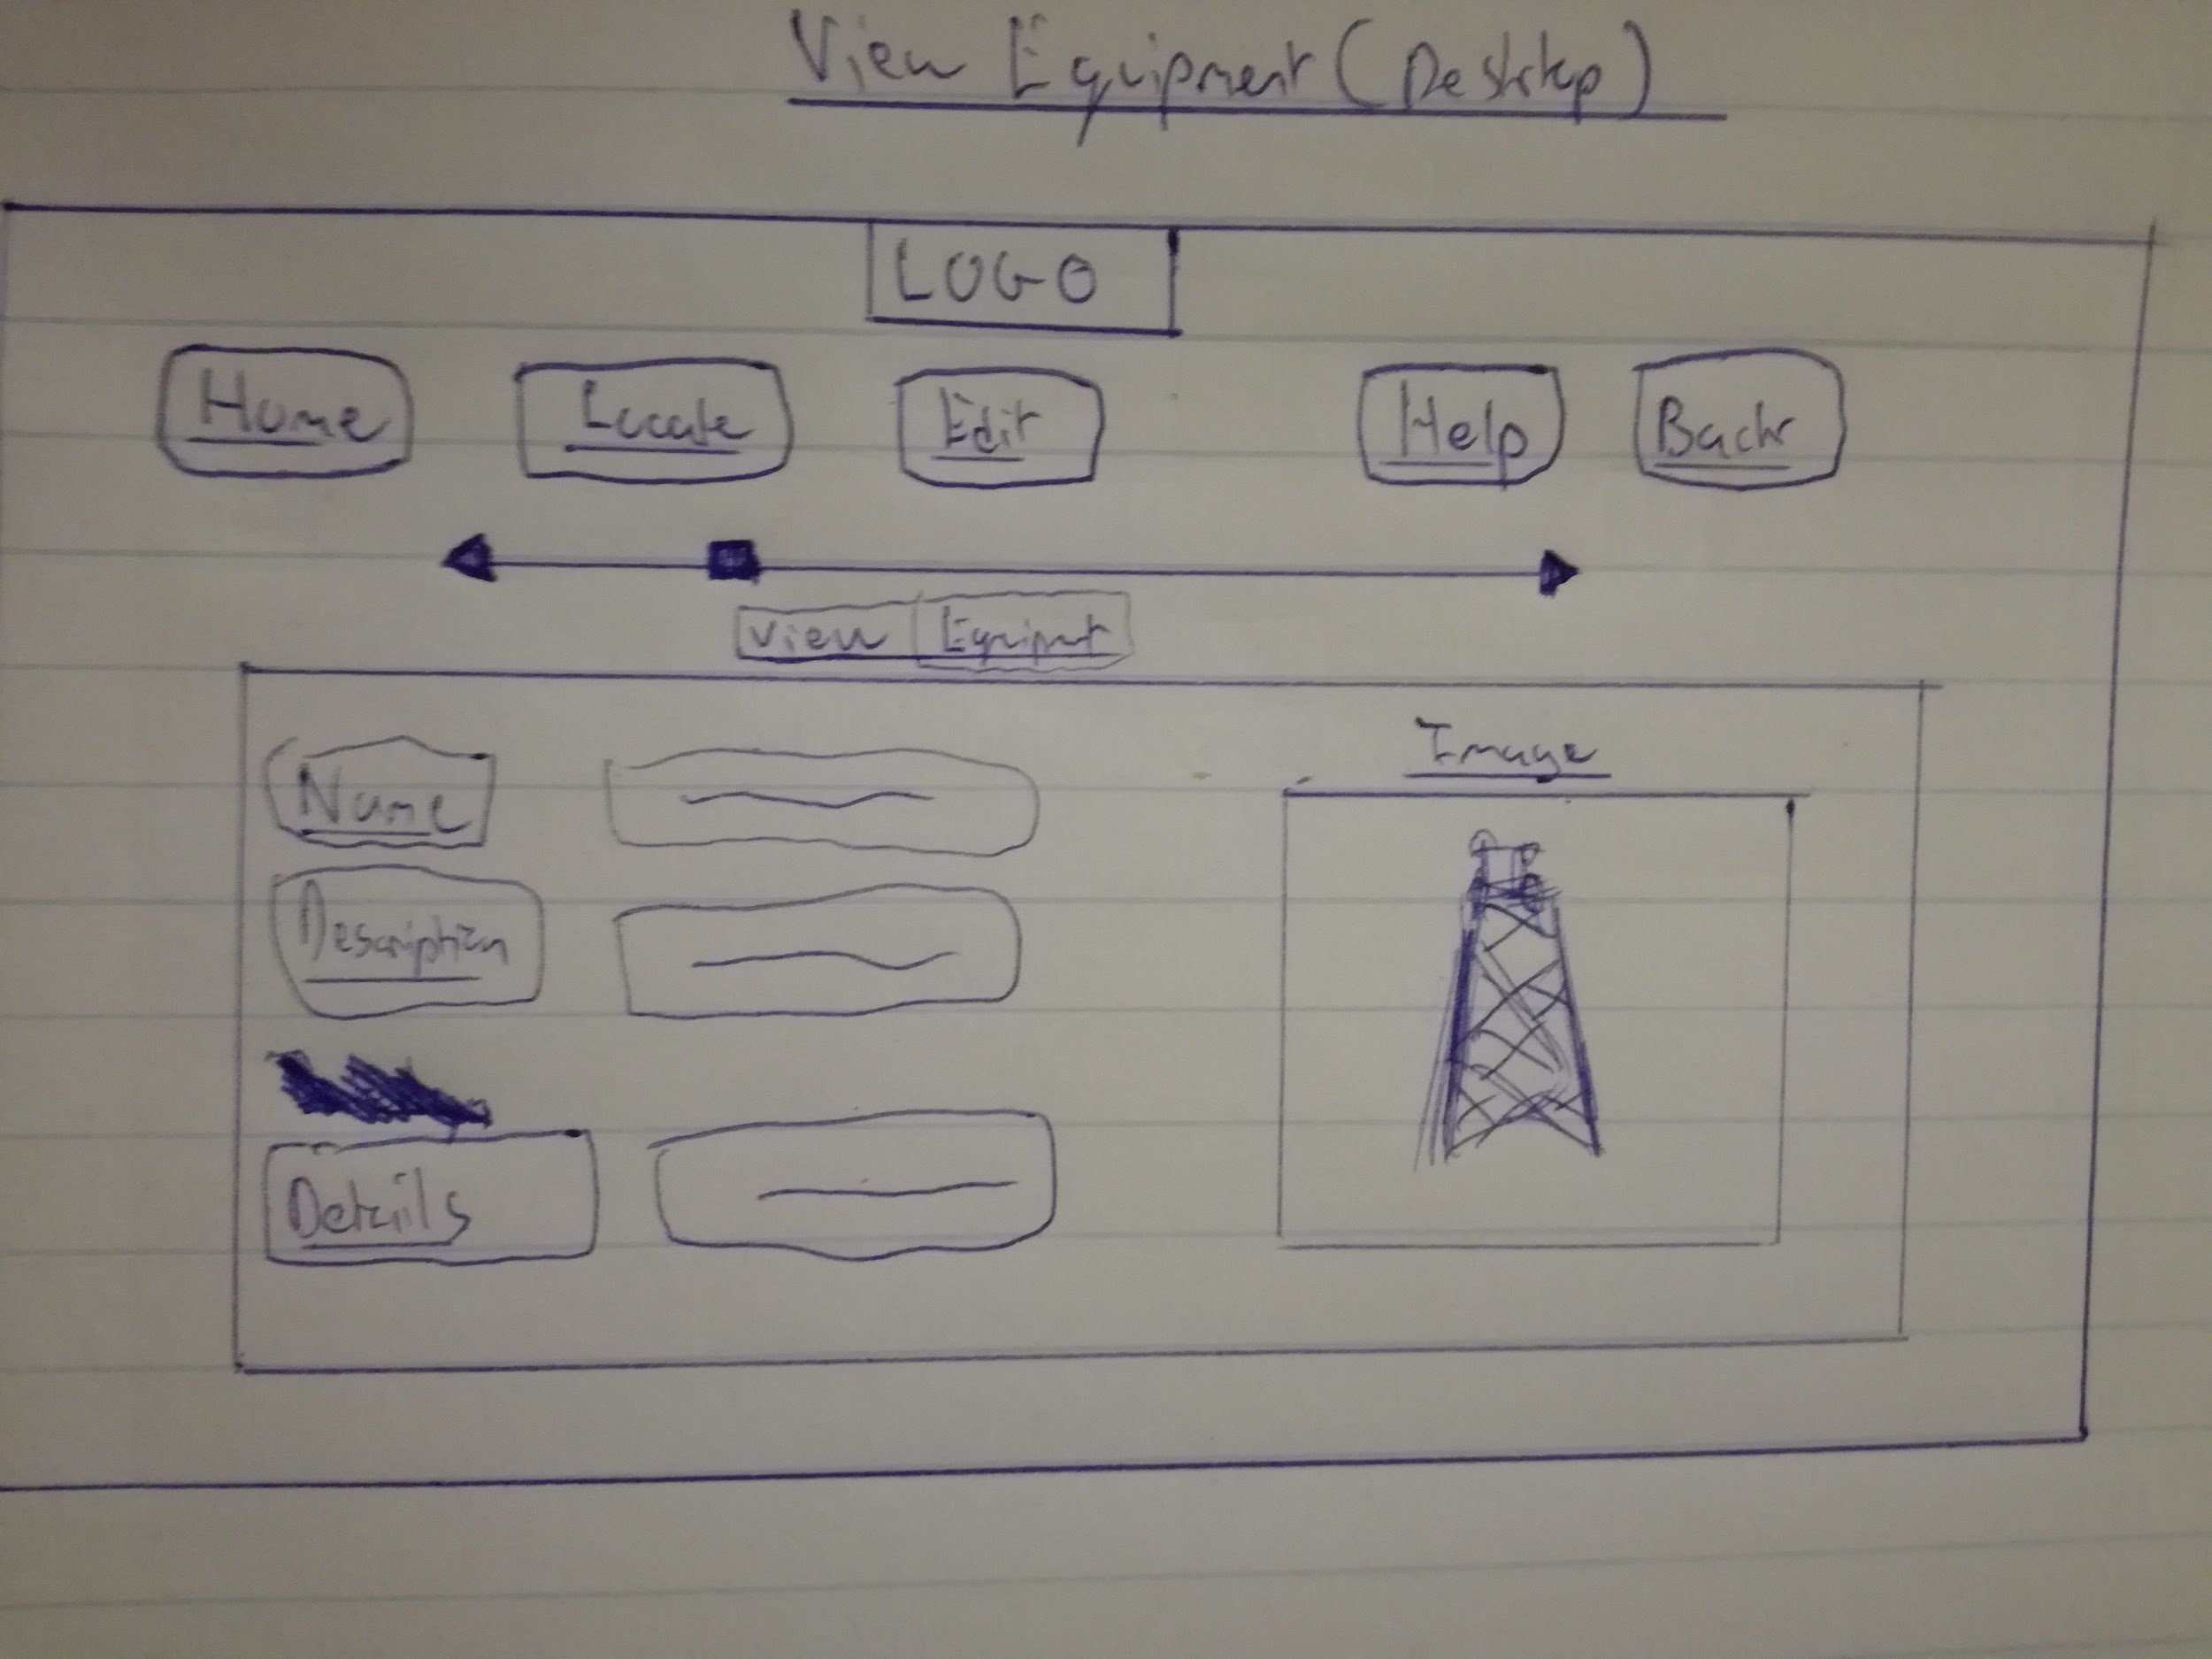

Add Equipment

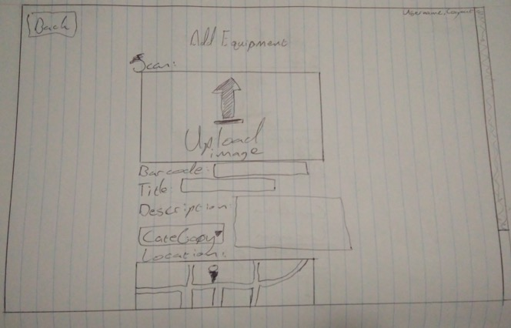

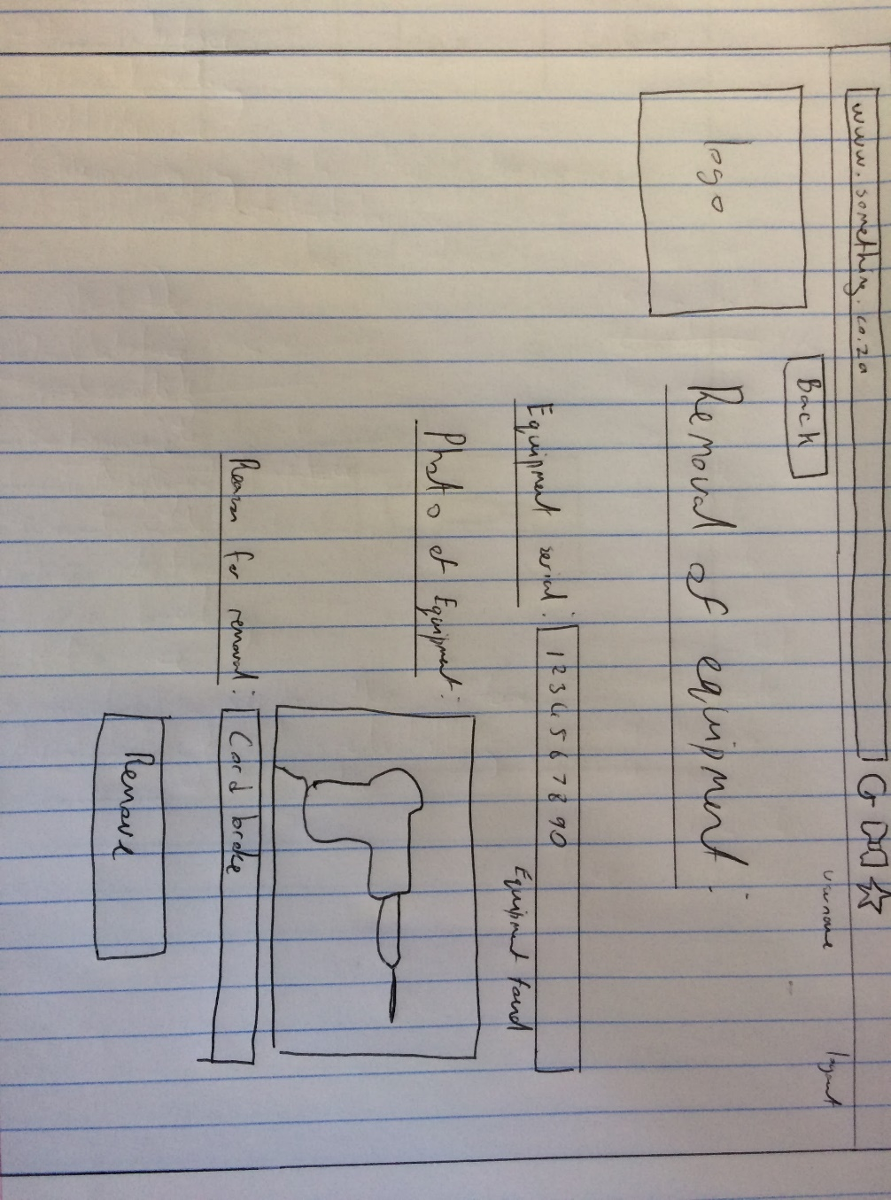Remove Equipment

Update Equipment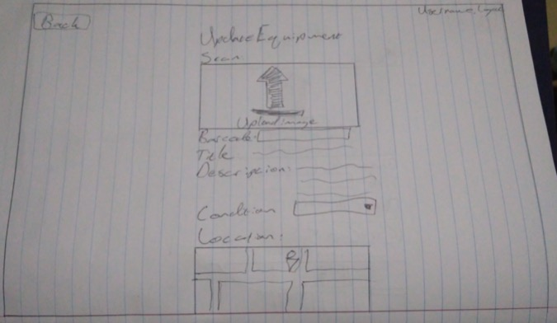

Locate Equipment

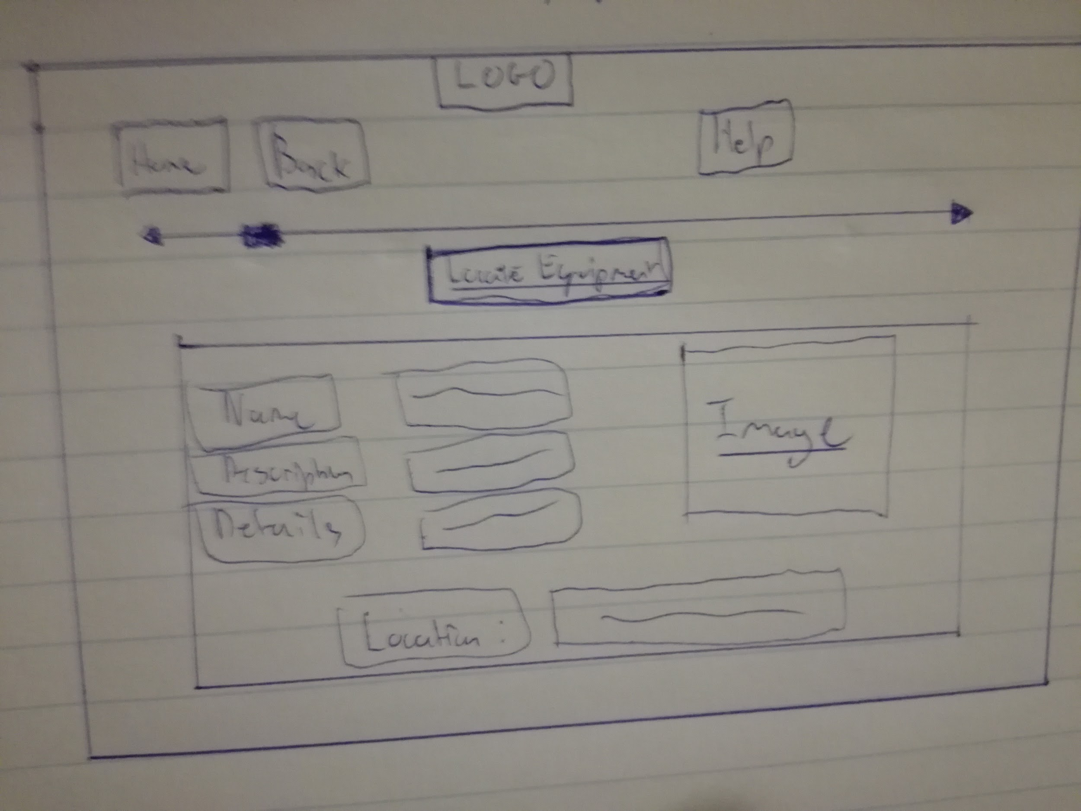

Add User

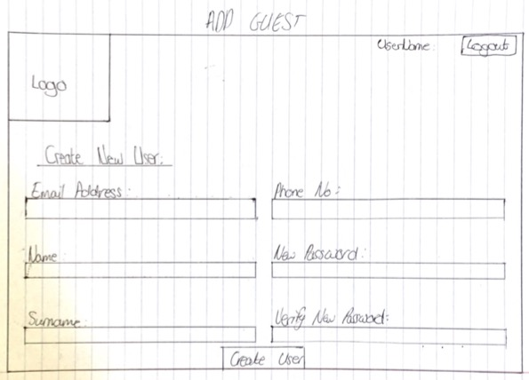

Remove User

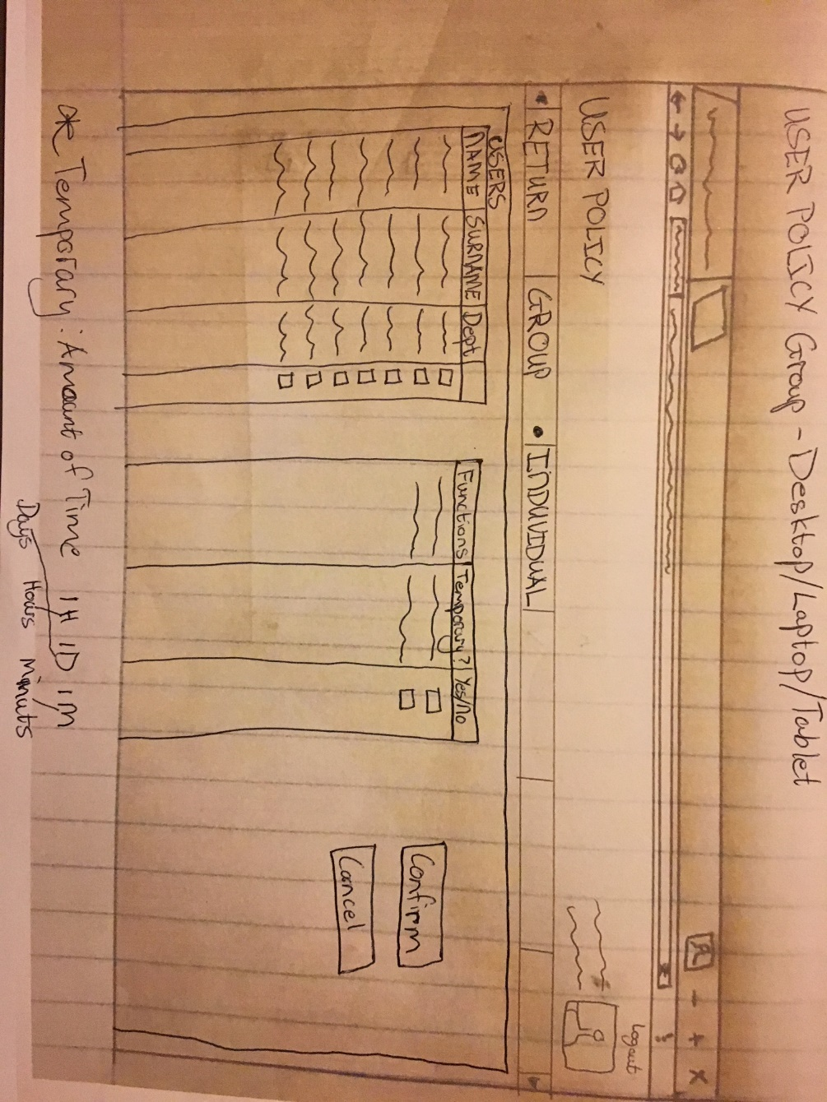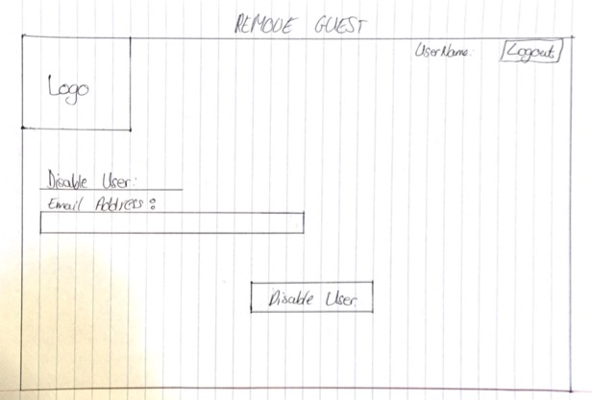

Group Policy

# 4. CONCLUSION

This project presents a great learning opportunity by comprehending the reality, which is working for a client in a sense. This project also presents a great opportunity for the group to experience new technologies while still being students in a learning environment.

This will project will also give us as a group to experience a working environment, as we will be filling a void in the local municipality's IT department to help create a system that is sorely needed, as they do not have the resources or the skills in which to do it.

This a high risk; high reward scenario for the group as we have never a project of this size and in a group with all this new technologies to learn and manage amongst ourselves.

We expect to gain a great deal of working knowledge of a real working environment and technologies in which we can apply out in industry.

5. APPENDICES

5.1 SLIDES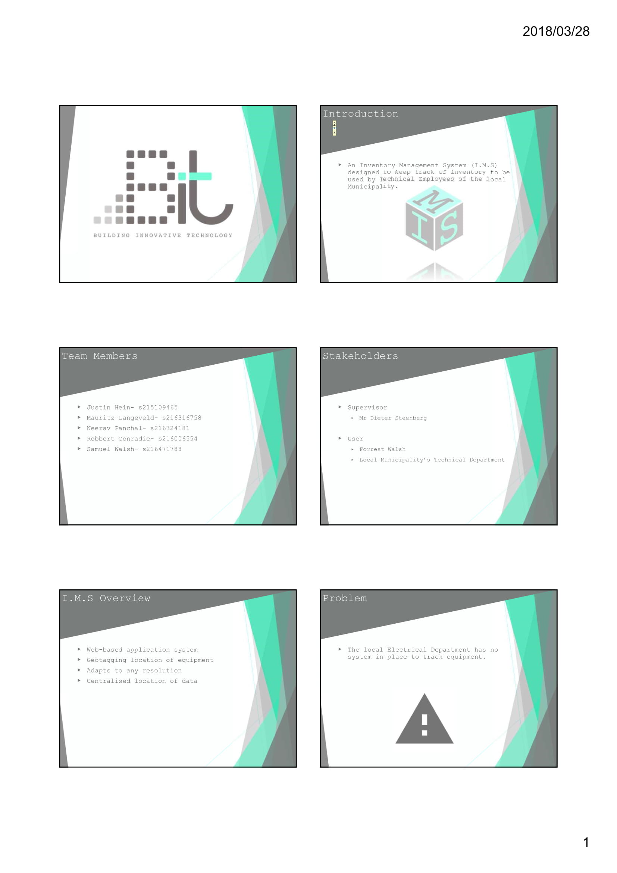

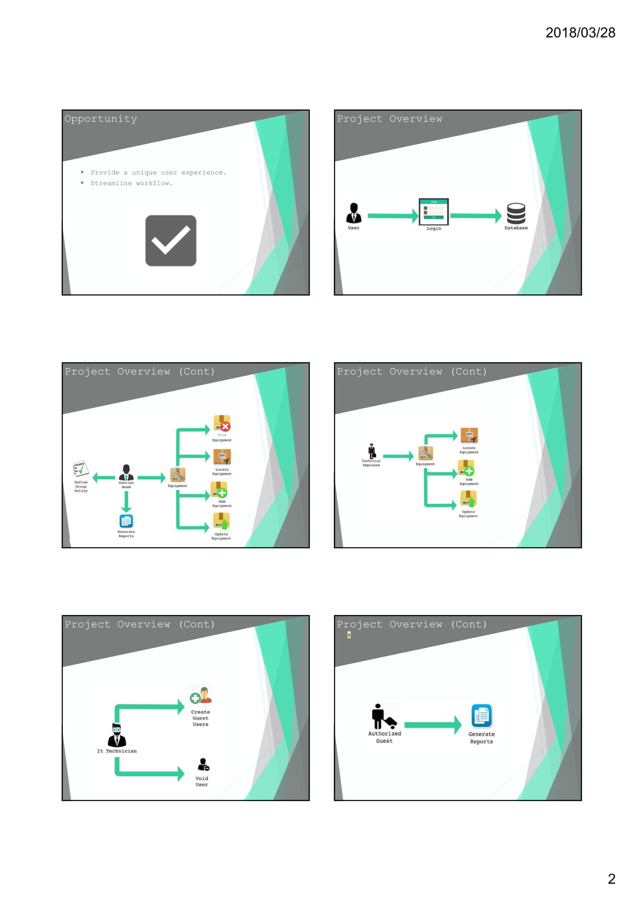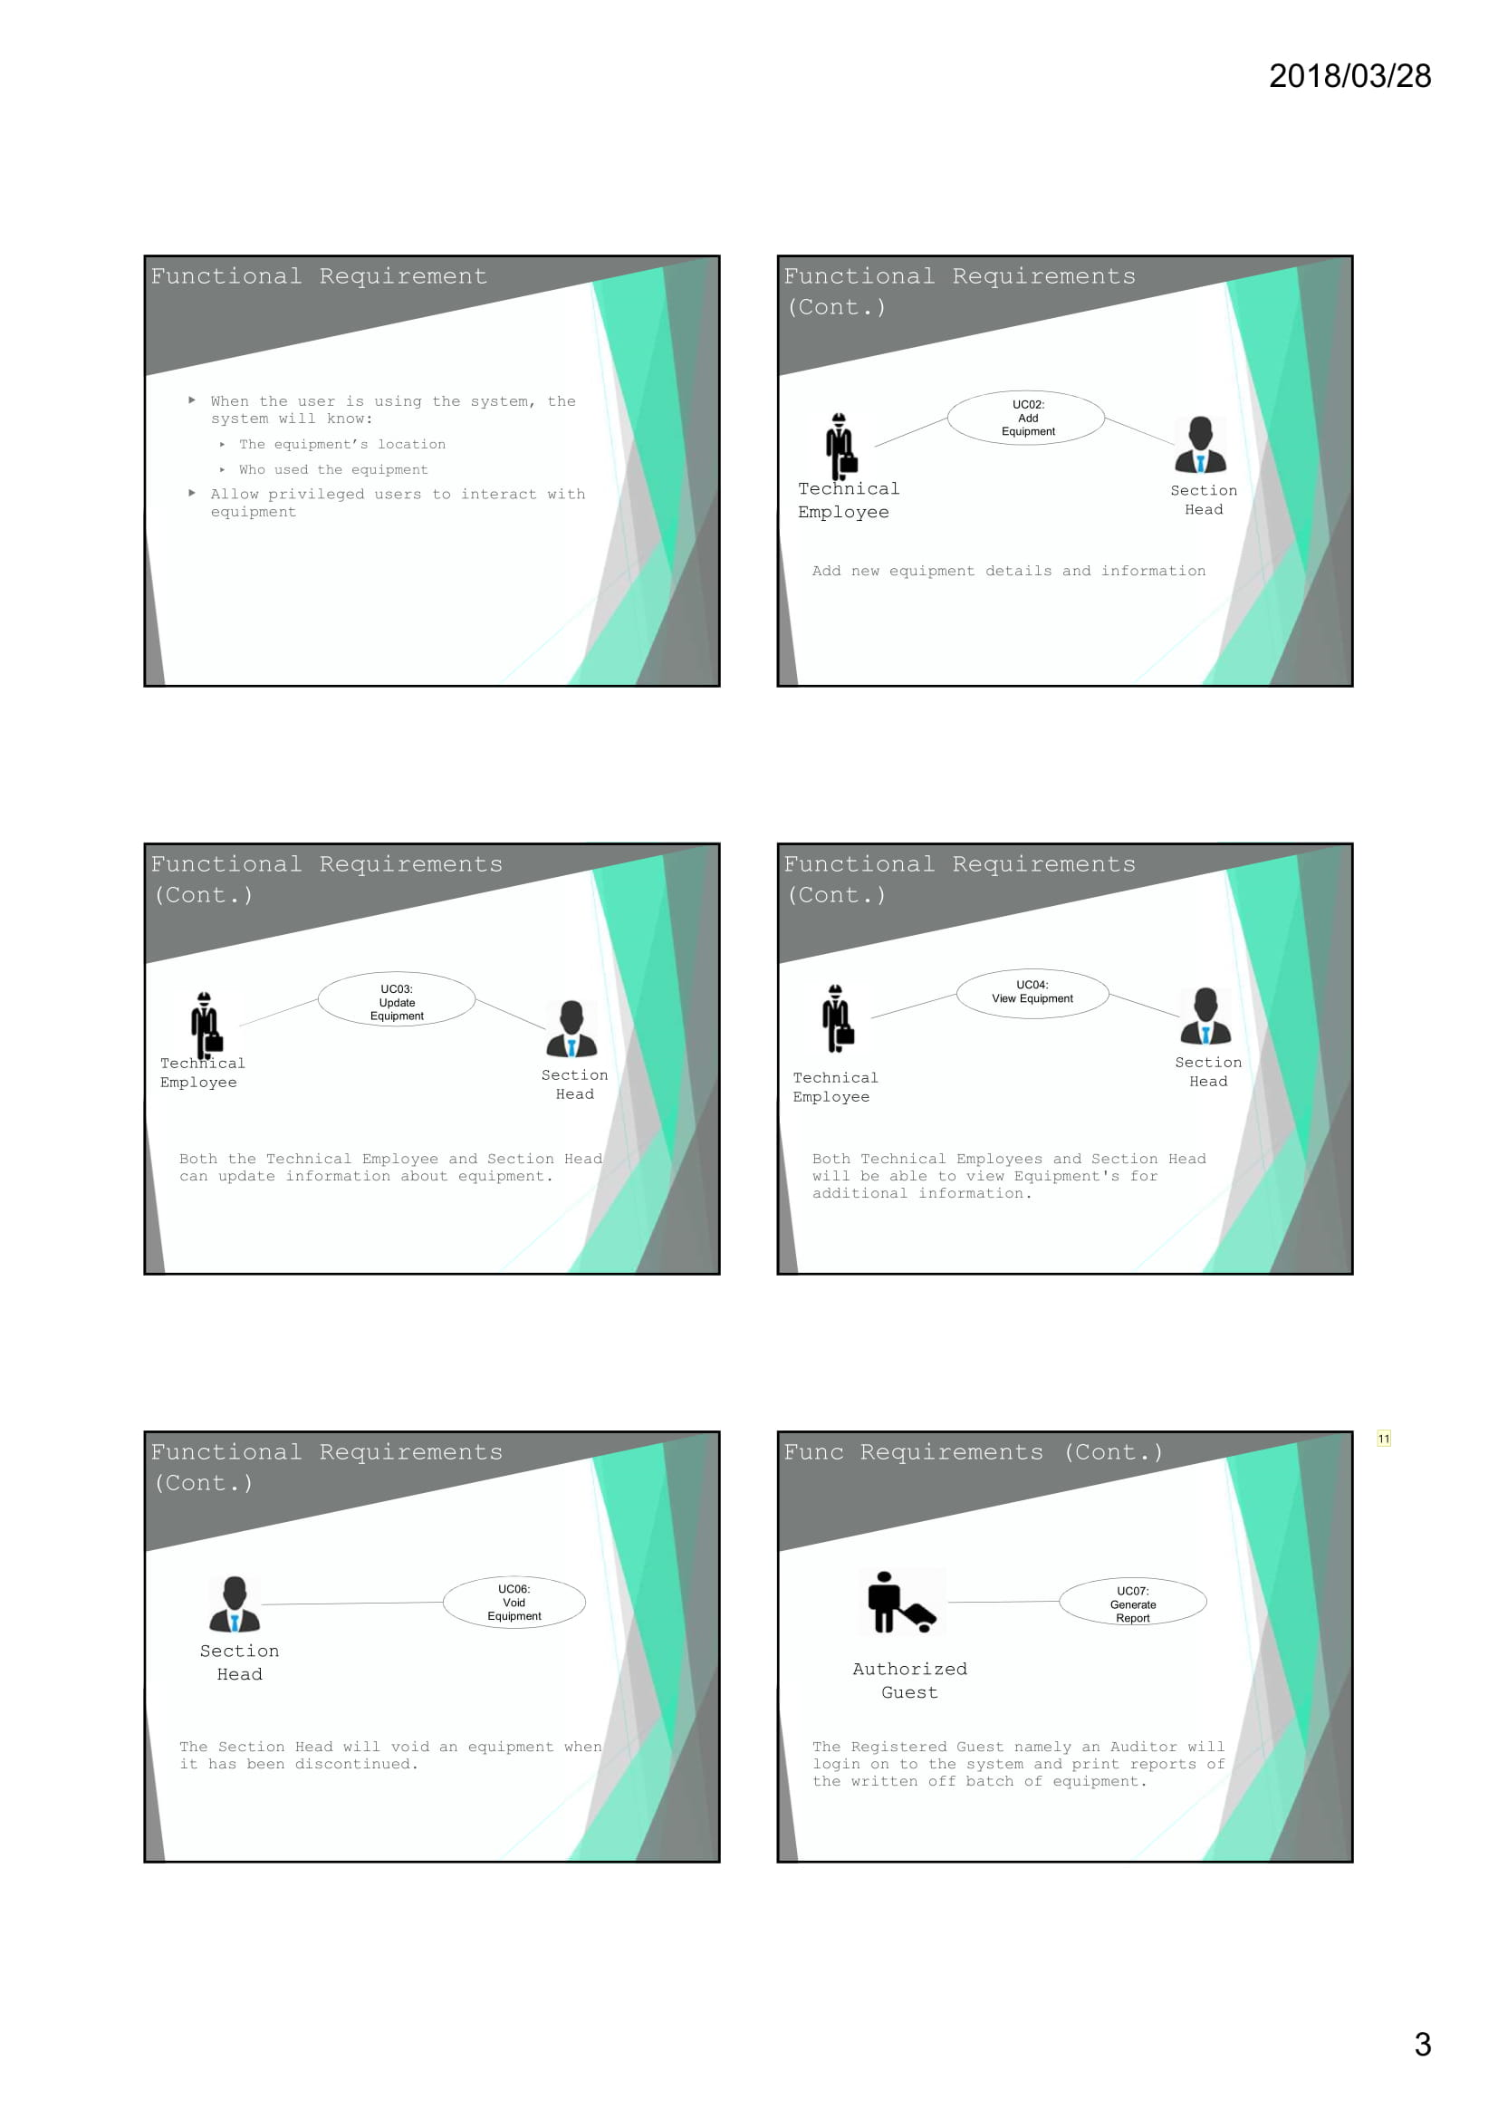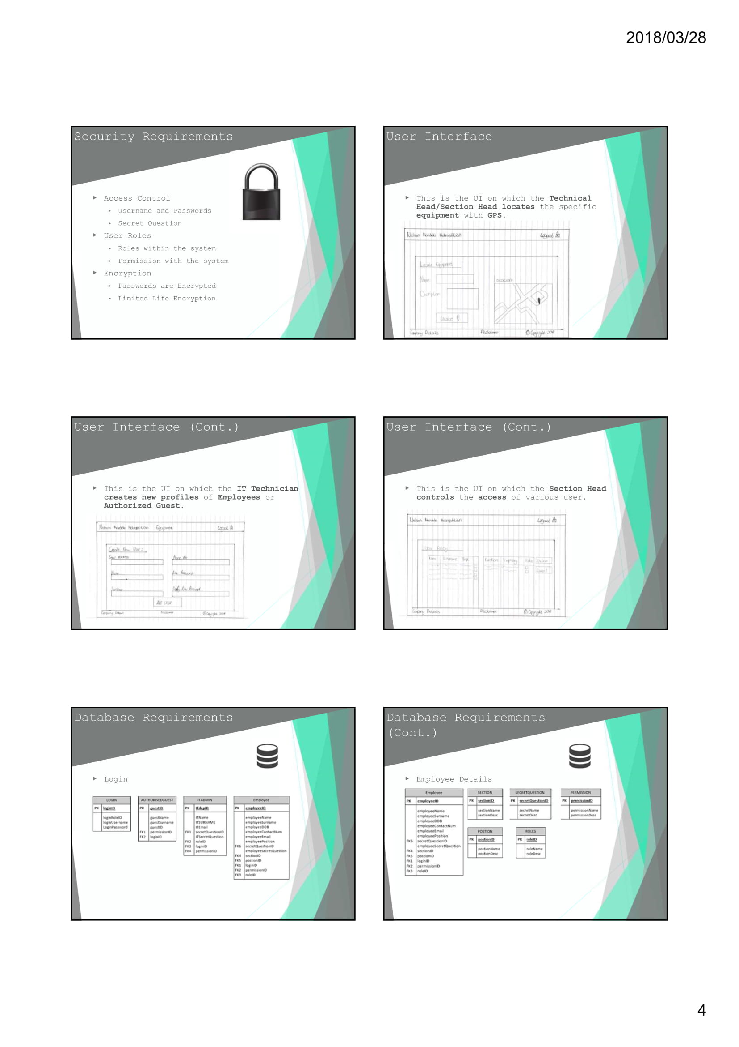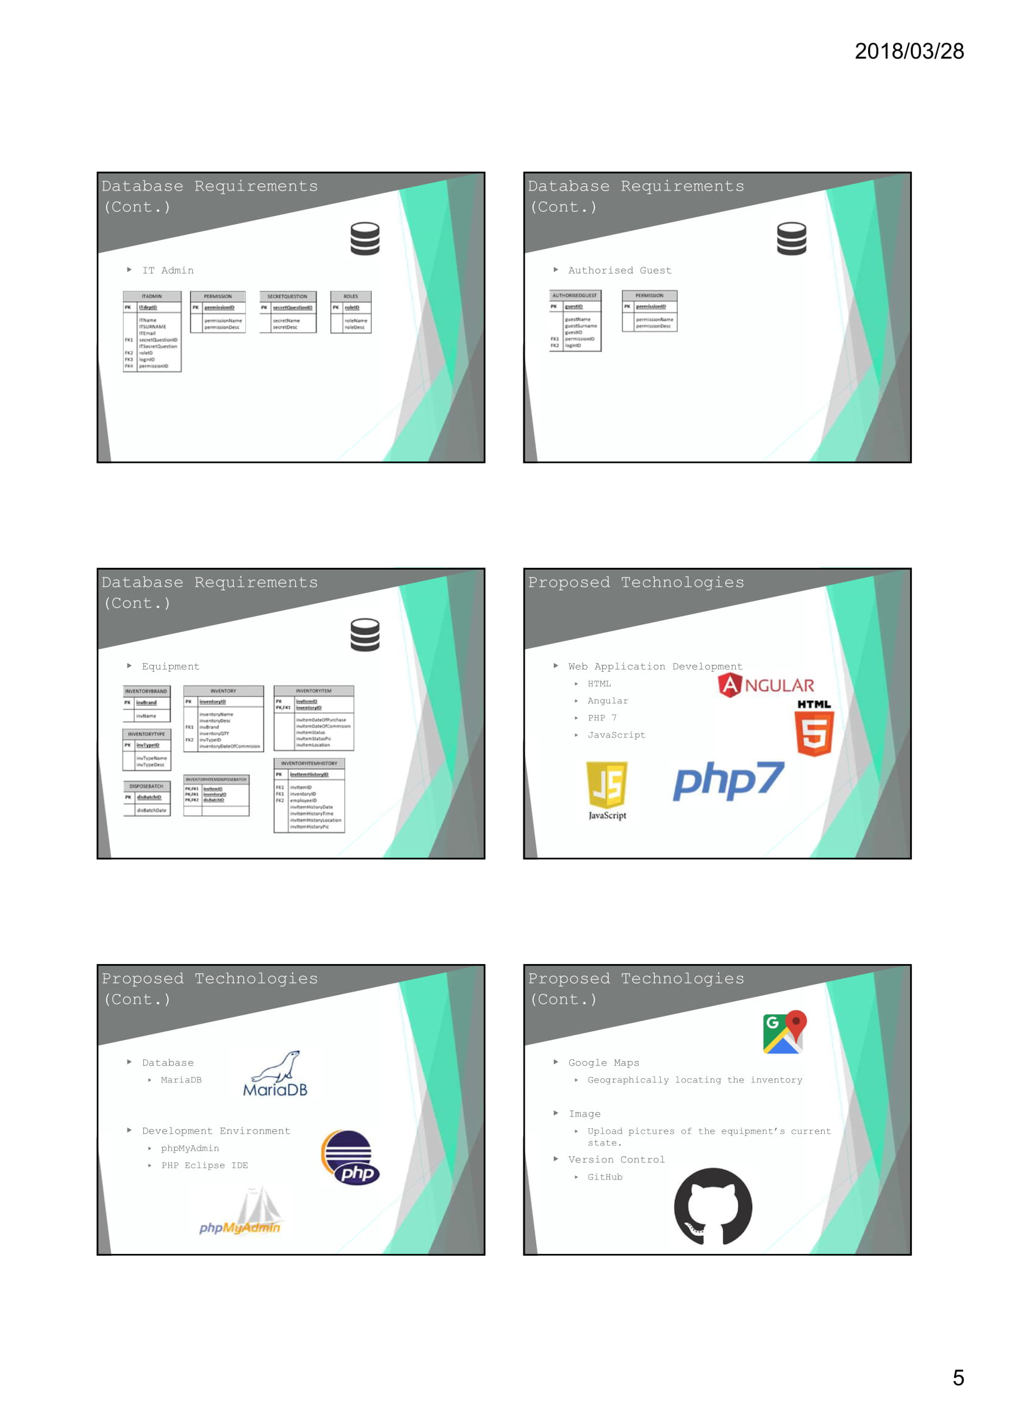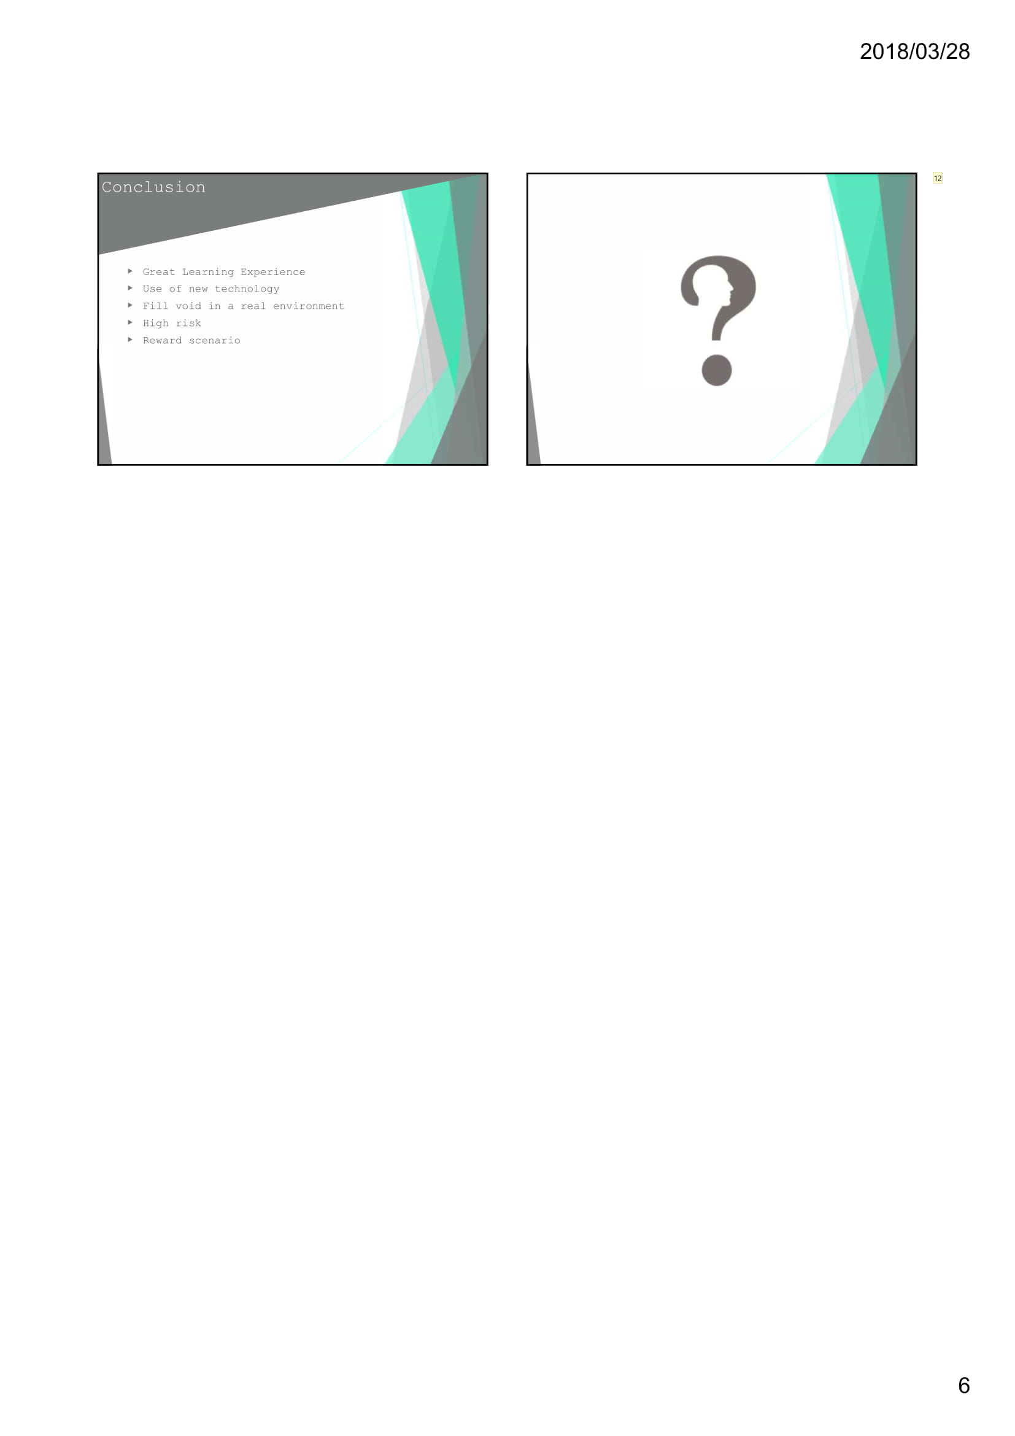

5.2 MINUTES OF MEETING

|  |  |  |  |
| --- | --- | --- | --- |
| **Project Group Name** | **Building Innovative Technology (B.I.T.)** | | |
| **Date of Meeting** | 16/03/2018 | **Time of Meeting** | 10:00-10:39 |
| **Location of Meeting** | Dieters Office | | |
| **Attendees** | **Attendee Name** | **Attendee Signature** | |
| Robbert J. Conradie |  | |
| Samuel J. Walsh |  | |
| Mauritz E. Langeveld |  | |
| Neerav S. Panchal |  | |
| Justin Hein |  | |
| Mr Dieter Steenberg |  | |

**Discussion Item/s**

|  |
| --- |
| 1. User management |
| 2. Security |
| 3. Proposed Technologies |

**Details of Discussions**

|  |
| --- |
| 1. We discussed how we can assign users privileges, we concluded that it would be best to assign users to a role that will dictate the functions the user has access to. |
| 2. We discussed how to handle security, we decided that the system will have a login so that only authorized users will have access to the system. |
| 3. We will be using MariaDB for our database, PHP 7, HTML for back-end programming, and Angular and JavaScript for the front-end programming. |